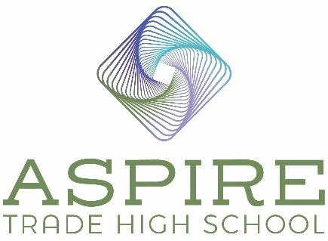

Aspire Trade High School BOD Meeting Minutes

Location: Zoom Call
Date: March 31, 2022
Time: 6:45 pm – 7:45 pm

In Attendance
Board Chair – Lauren Nicholson
Vice Board Chair – Jennifer Nichols
Secretary – Marianna Sartin
Treasurer – Jim Secunda
Absent
Board Member – Amanda Cuff
Agenda Items

- Review and Approve January 27, 2022 Minutes
Motion: James Secunda: Motion to approve as written. Jennifer Nichols: Seconds the motion.
Motion Approved: Voted Yes: Jennifer Nichols, James Secunda, Lauren Nicholson, Marianna Sartin.

- Meetings

- CSAB Ready to Open Meetings
Because we are opening in the fall of 2023, we now have a smaller list of items to complete. CSAB has determined that most of the remaining assignments should be completed in 2022-2023 our actual ready to open year. Completed documents that need updating will be resubmitted in the next RTO classes.

- June 8-9 is the New Charter Leaders Institute, Raleigh
We are not required to attend this June. The ATHS Principal will attend this meeting in 2023. RTO meetings must be attended by a minimum of 50% of the board of directors.

- Marketing

- Website hits and marketing
The board agrees we need to be really focused on increasing our student enrollment and have selected a group of activities to focus on for the next two months. We will focus on printing additional flyers for distribution and will create/compile needed materials in boxes for each board member to distribute. The BOD will start reaching out to tutoring centers, parent advocacy groups, mom’s groups, YMCA’s, local EDC and chamber offices to place ATHS materials. Jennifer will schedule meetings with the churches to begin scheduling meetings to reach potential students.

- Facebook Ads – March
We increased the time our Facebook ads to run from 2 weeks to 4 weeks a month beginning in March. We had 11 submissions for the month of March. In February when we only ran the ads for 2 weeks and we had 10 submissions. We do not believe it is worth the extra money to keep running the ads for the full month. We will run them for 4 more weeks in April to be sure. The BOD agrees if April’s number remains similar, we should reduce the ads back to 2 weeks a month.

- Student Interest/Enrollment- Totals to Date
We have 83 submitted web forms for interested students.

- Construction Update
We met with Samet builders, and our build is scheduled to begin on May 1st. The timeline for the build is 12 months and they are promising us keys to the building by June 2023. They are currently accepting bids for sub-contractors. We will meet with Samet to make the subcontractor selections. If a sub-contractor discounts their price to support our school, we will consider it an in-kind donation and have them on the naming wall of donors.

- Financing Package Update
Our RFP is about 70% complete. We want it finalized this week. We need an attorney (borrower’s counsel) to negotiate with the banks. Lauren received a $15,000 quote from Mary Nash in Raleigh. Lauren’s attorney contact in Florida would do it free however we are required to have a NC attorney. Lauren also reached out her contact at Moore and VanAllen and he will get back to us. They would like to work with us on the fee side.

- Lab Partner Update
Trane Technologies will be visiting our school and they will help us design the lab. Muller Craft and Trade Academy is helping with lab layout (tile). Jennifer is meeting with Metrolina Greenhouses, SteelFab, Metrolina Woodworking(Millwork), Pete Budkco (former NBA player) for information on farming which he is heavily involved in now. We are getting lots of contacts and people reaching out to us.

- Fundraising
The Aspire board is working hard on fundraising contacts.

- Next Meeting
Our next meeting is scheduled for Thursday, April 21st at 6:45.

- Motion: Motion to adjourn meeting. Marianna Sartin: Motion to adjourn.
Lauren Nichols seconds the motion.
Motion Approved: Voted Yes: Lauren Nichols, Jennifer Nichols, Marianna Sartin, and James Secunda.

- Meeting adjourned at 7:45pm

