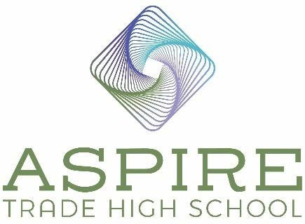

Aspire Trade High School BOD Meeting Minutes

Location: Zoom Call
Date: September 22, 2022
Time: 6:45 pm – 7:00 pm

In Attendance
Board Member – Jennifer Nichols Secretary – Derek Partee
Board Chair – Jim Secunda

Absent

Vice Board Chair – Dale Halton
Treasurer – Lauren Nicholson

Agenda Items

- Review and Approve August 25, 2022 Minutes

Motion: Derek Partee: Motion to approve as written. James Secunda: Seconds the motion.
Motion Approved: Voted Yes: Jennifer Nichols, Derek Partee, and Jim Secunda.

2.) Construction Update

We have four full walls up now and we are on track to be finished by June. Jennifer will send some photos to the BOD to show the progress.

Potential Lab Updates

Jennifer met with Metrolina Greenhouses on Monday and she will be having a meeting with the two CEO’s next week. We are hoping they will provide us a greenhouse and a Freight Farm hydroponic lab. They are very excited to have our students as potential employees in the HVAC, plumbing, welding and fabrication areas. All those fields are used at Metrolina Greenhouses because they build a lot on site. We are trying to meet with the Gene Haas Foundation regarding a CNC machining lab. Jennifer will be speaking on 94.7 this Saturday with the group Put Tools in Schools. They have told her that we should approach Bosch regarding CNC machining, 3D printing and an automotive lab. Apparently, Bosch reached out to CMS a few years ago regarding building a trade high school and had no response. Put Tools in Schools will set up an introduction for us. Jennifer also had an initial meeting with Microsoft and has an additional meeting scheduled. They are interested in assisting us with IT/data science. All our partners are coming to our event on October 8th from 10:00 – 2:00 and giving demonstrations and we are excited to see that and meet the student families.

4.) Marketing

Website hits – We are averaging 31 average visits per day, 19 new visits per day, and have increased from 953 to 1101 new visits since August 25th.

Student Interest/Enrollment Forms – Totals to Date

Our interested student list has grown from 155 to 250.

Facebook – We have grown from 191 to 250 followers. Our reach has grown from 507 to 3,428.

Flyer distribution

Marianna and Luke have been taking the table and flyers to different locations and meeting with families to get them signed up for the student interest list. They are dropping off flyers in mailboxes and at businesses. We have just about run out of our initial 5,000 flyers and will be ordering 10,000 more. Luke and Marianna will also drop off flyers at K-8 schools and they were at Ada Jenkins today.

Billboard Campaign Update

The billboards are still running, and we have them until approximately November 4th (4-month contract).

5.) Finance Update

We should have the terms for you at our meeting on Tuesday to sign with EcoFin.

7.) Next Meeting
Our next meeting is scheduled for Thursday, October 27th at 6:45.

8.) Motion: Motion to adjourn meeting. Jim Secunda: Motion to adjourn.
Derek Partee seconds the motion.
Motion Approved: Voted Yes: Jennifer Nichols, Derek Partee, and Jim Secunda.

10.) Meeting adjourned at 7:00 pm.

