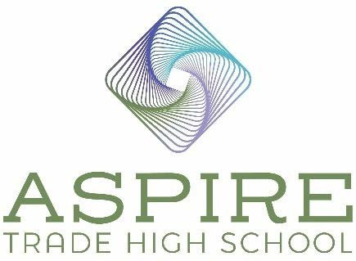

Aspire Trade High School BOD Meeting Minutes

Location: Zoom call
Date: December 7, 2022
Time: 4:30 pm – 5:00 pm

In Attendance

Board Chair – Jim Secunda

Secretary – Derek Partee

Board Member – Jennifer Nichols

Treasurer - Lauren Nicholson

Absent

Vice Board Chair – Dale Halton

Agenda Items

- Called Meeting

This meeting was called to approve the: RESOLUTION OF THE BOARD OF DIRECTORS OF Aspire Carolinas Foundation, inc. for itself and as sole member of aspire trade holdings llc RELATING TO THE ISSUANCE OF PUBLIC FINANCE AUTHORITY Educational Facilities revenue Bonds (aspire trade high school Project) Series 2022

Jennifer confirmed that the board received and reviewed the Resolution. She opened the floor to any comments or questions on the Resolution. Derek asked if an additional board signature could be added to the document in addition to his signature. He also asked if we needed fiduciary liability insurance to protect the loan. Jennifer called Mary Nash, our attorney, to answer the questions. Mary stated that yes, we could add Jennifer’s signature as an additional signature on the document. Ms. Nash stated that on loan agreements there is not an option to purchase additional insurance since the value of the land (10 acres) and the school (65,000 square foot building) secures the loan in case of default. We do have business interruption insurance – that is part of a casualty risk insurance – that would pay a year of debt service should an unexpected event occur that disrupts business, for example hurricane damage. In addition, as we are constructing the building right now it is also covered by a builder’s risk policy. She stated the loan was set up to have us only pay interest for the first six years at a fixed rate. This allows us to refinance after 3 years at a lower rate and keeps our payments lower while we get the school up and running. There were no other additional questions.

2) Motion: Lauren Nichols: Motion to approve the: RESOLUTION OF THE BOARD OF DIRECTORS OF Aspire Carolinas Foundation, inc. for itself and as sole member of aspire trade holdings llc RELATING TO THE ISSUANCE OF PUBLIC FINANCE AUTHORITY Educational Facilities revenue Bonds (aspire trade high school Project) Series 2022 Motion Seconded: Derek Partee Motion Approved: Voted Yes: Jennifer Nichols, Derek Partee, Lauren Nicholson and Jim Secunda.
3) Motion: Lauren Nichols: We have resolved to accept the following loan closing documents and have Derek Partee and Jennifer Nichols sign them tomorrow (Thursday, December 8, 2022). The documents include: Due Diligence Request and Questionnaire, Pre-Posting Questionnaire, Closing Certificates, Loan Agreement, Lease Agreement, Memorandum of Lease, Deed of Trust, Tax Regulatory Agreement, Tax Certificate, LOM Certification, Continuing Disclosure Agreement, Bond Purchase Agreement, Deposit Account Control Agreement, Collateral Assignment of Lease Agreement, Collateral Assignment of Contract Documents, Guaranty Agreement, and Closing Memorandum. Motion Seconded: Jennifer Nichols Motion Approved: Voted Yes: Jennifer Nichols, Derek Partee, Lauren Nicholson and Jim Secunda
4) Motion: Jim Secunda: Motion to adjourn. Motion Seconded: Lauren Nicholson Motion Approved: Voted Yes: Jennifer Nichols, Derek Partee, Lauren Nicholson, and Jim Secunda.

Meeting adjourned at 5:00 pm

