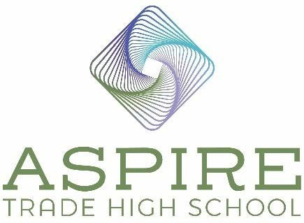

Aspire Trade High School BOD Meeting Minutes

Location: Dale’s residence
Date: December 20, 2022
Time: 9:45 am – 10:10 am

In Attendance

Board Chair – Jim Secunda

Vice Board Chair – Dale Halton

Secretary – Derek Partee

Board Member – Jennifer Nichols

Treasurer -Lauren Nicholson

Agenda Items

- Review and Approve November 15, 2022 Minutes

Motion: Jim Secunda: Motion to approve as written. Lauren Nichols: Seconds the motion.
Motion Approved: Voted Yes: Jennifer Nichols, Derek Partee, Dale Halton, Lauren Nicholson and Jim Secunda.

Construction Update

All the walls are up and we are on schedule. We will be able to accept furniture in June. Jennifer is worried about damage to the furniture and is thinking about just having the administration wing furnished initially. They will fully set up and unwrap all our furniture upon installation. Jim asked if the building will be secure to have furniture in it? Jennifer stated that yes, all the doors will be locked and an alarm system will be installed. We are having the Topping Out ceremony on January 6, 2023.

Student Enrollment Applications

We have received 60 applications to date. Over 40% are not from the interest list so Marianna is going to call candidates on the interest list this week to check in with them regarding enrollment. We have a high number of sophomores enrolling which is great. Our financing is almost complete and Jennifer and Jamie have been working hard to complete the budget to ensure accuracy. It is critical that we focus on raising donations and increasing enrollment.

Principal Search

Hiring our new principal is a priority and will also help us increase enrollment and complete all our ready to open tasks. We are hopeful we will have a decision by January 15th. We have a very strong group of final candidates to select from and they all have CTE and charter school administration experience. We will have the board be a part of the third interview when it is scheduled.

Marketing
- Aspire Trade High School Facebook page “likes” increased from 275 to 337. Our ad reach increased from 66,555 to 106,900 (estimated to have seen a post from us). We have had 6,000 interactions with our ads (liking them, sharing them or clicking through to the website). We are doubling our Facebook advertising budget for the next two weeks. We are marketing across Mecklenburg and all the northern Charlotte surrounding counties. We have widened our demographic to include all incomes and ages for the widest reach.
- Website
31 average visits per day, maintaining 26 new visits per day average, 2244 to 3188 new visits (total)

Derek recommended we look at geofencing advertising and Cathy will get some costs and recommendations to Jennifer. Jennifer said the tag line should have “free tuition charter trade high school” in it. Chris Williams still needs to call Jennifer for an interview at WTVI. Jennifer will request to go back on Tools in Schools. We will reach out to Spectrum and WBTV to see if we can set up some coverage. We will ask William Lee from LKN Publications to come out on January 6th. We will have a photographer there too. Jennifer is being featured in an interview with Charlotte Today.

Next meeting

Our next meeting is scheduled for January 17, 2023.

Motion: Motion to adjourn meeting. Derek Partee: Motion to adjourn.
Lauren Nicholson seconds the motion.
Motion Approved: Voted Yes: Jennifer Nichols, Derek Partee, Lauren Nicholson, Dale Halton and Jim Secunda.

