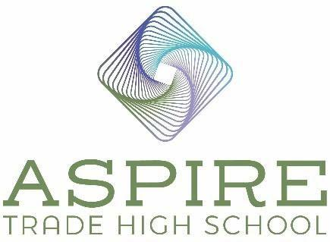

Aspire Trade High School BOD Meeting Minutes

Location: Boomerang Architecture
Date: June 21, 2023
Time: 9:45 am – 11:00 am

In Attendance

Board Chair – Jim Secunda

Secretary – Derek Partee

Board Member – Jennifer Nichols

Treasurer -Lauren Nicholson

Agenda Items

- Review and Approve May 24, 2023 Minutes

Motion: Derek Partee: Motion to approve as written. Jim Secunda: Seconds the motion.
Motion Approved: Voted Yes: Jennifer Nichols, Derek Partee, Lauren Nicholson and Jim Secunda.

Construction Update

The electrical is still not complete and we have issues with the store front. The glass and frames and the glass in the Atrium have all just been received and the building is not dried in. We are still waiting for approval for RTAP 2. We need to close out the basins. Spectrum did not install our fiber line all the way out to the building. They are scheduled to complete is soon. Our Temporary Certificate of Occupancy (TCO) is now likely to be July 7th or 8th. The Certificate of Occupancy (CO) releases the funds we need from the state to pay the teachers. We’ve asked for a meeting with the Town of Huntersville to resolve the RTAP issues so we can get our TCO. If needed we could use our alternative calendar to delay the opening date of the school. We really want to be able to get more families in to tour the school.

Student Enrollment Applications

We have 195 enrolled and 210 applied. We are working with the families that are still trying to decide. We are excited that we will have a diverse student population and staff. We have a great mix of kids. We will need another bus driver and we are hoping to enroll 50 more students. We are going to post 300 signs about the school all over town soon. Derek recommends Signs on the Cheap.

Teacher contracts

- Motion: Jennifer Nichols: Motion to approve all the new hires listed below and formalize their contracts. Lauren Nicholson seconds the motion.
Motion Approved: Voted Yes: Jennifer Nichols, Derek Partee, Lauren Nicholson and Jim Secunda.

Contracts Approved (Last Names withheld for privacy):
Front Desk/Receptionist – Abagail
Office Manager – Suzanne
Science Teacher – Anika
Math/Science Teacher and Bus Driver – Kirby
History Teacher – Brandon
English/Social Studies Teacher – Brittany
EC and Teacher – Erin
English Teacher – ½ Time position – Claire
History Teacher – ½ Time position – Karen
Carpentry and Masonry Teacher – David
Culinary Teacher – Lakeya
Welding Teacher – Norge
Medical Coding and Medical Assisting Teacher – Leslie

We are close to all our positions being filled. We have some math interviews scheduled and a plumbing person in contact with us. Almost all of our teachers are certified. We can hire our remaining trade teachers as lateral entry if needed and Meghan will train them. Jennifer feels really positive about these new hires, we have waited for the right person each time. We posted the jobs everywhere we could think of. We had candidate with a reference that came back negatively and we had to rescind the offer. The teachers will be starting on August 14th.

- Marketing

- Facebook ads to run through 7/31.
- Facebook followers 459 to 480
- Last 28 days – 60, 508 reach (85,156 last month) estimated to have seen a post from us.
- Last 30 days 5079 ad link (6,105 last month) link click throughs.
- Website 173 to 102 average visits per day, from 112 to 64 new visits per day average, 19,658 to 21,576 new visits (total)

Our Facebook ads will run through July 31st. We added a Math specific hiring post. Our numbers have been down, possibly because of saturation of these ads since January. The board thinks the summer and vacation has lowered our numbers. Derek feels once the building is complete there will be a waitlist to attend. We will add photos of the school to the website.

- Donors

We have not found a partner for the data science lab yet, but it is not an expensive lab to complete. We are still looking for a data science and HVAC instructor. Milwaukee Tools has agreed to be our tool provider. They are education driven and will bring resources and training to our school. They will provide us with discounts and have an endowment that we have requested they help provide us with free tools.

Next meeting

Our next meeting is scheduled for Tuesday, July 25, 2023 at Boomerang Design

Motion: Motion to adjourn meeting. Jim Secunda: Motion to adjourn.
Lauren Nicholson seconds the motion.
Motion Approved: Voted Yes: Jennifer Nichols, Derek Partee, Lauren Nicholson, and Jim Secunda.

