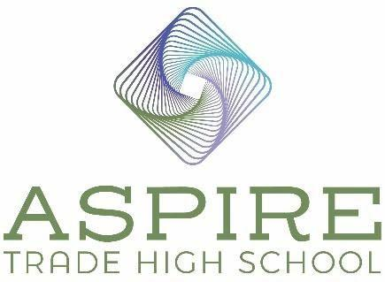

Aspire Trade High School BOD Meeting Minutes

Location: ATHS Cafeteria
Date: October 29, 2024
Time: 5:00 pm – 6:00 pm

In Attendance

Board Chair – Derek Partee

Vice Chair – Heidi Bertino-Daum

Treasurer - Jenny Miller

Principal – Jennifer Nichols

Secretary – Heath Edmiston

Agenda Items

- Review and Approve September 24, 2024 Minutes

Motion: Heidi Bertino-Daum: Motion to approve as written. Jenny Miller seconds the motion.
Motion Approved: Voted Yes: Heidi Bertino-Daum, Derek Partee, Heath Edmiston and Jenny Miller.

- Update on site issues yet to be resolved.

- Lights in courtyard
(Heath Edmiston) They are complete.
- “As builts” and bonds
(Heath Edmiston) They are under their 4th review. We should hear back soon. Jennifer stated that the Town of Huntersville had said it would be done by October 31st.
- Plumbing and electrical in the labs
(Heath Edmiston) We are just waiting for 6 hose bibs to finish the plumbing; they have been ordered. The electrical work in the labs started last week and should be complete by Thanksgiving.

- Student Enrollment 276
We currently have 276 students enrolled. Derek will bring his Town of Huntersville contacts to tour the school. We got a bump in interest after the Jamie Boll interview piece aired. Davi has shared it on the ATHS website and Facebook.

- State funding of increased enrollment still delayed/annual audit delayed.
We are still delayed in getting the funding from the state for our increased enrollment.

Our annual audit is also delayed (Rebecca Barr, CPA is completing). This is because of the issues in western NC. We expect to have the audit completed by Thanksgiving. We need to forward it to TSERs (state retirement system) so they can evaluate our continued enrollment the state retirement system. The initial feedback is that financially the first year looks good for us.

- Staffing

a) 2024-2025 contracts for board approval (requires motion/vote).
The following contracts were handed out to the board to review and vote on hiring:

C. Clark – part-time HVAC teacher
C. Phelps – new counselor – here 3 days a week (M, W, F)
T. Scott – new science teacher
I. Crabill – new culinary teacher

Motion: Jenny Miller: Motion to approve the above-listed employment contracts. Heidi Bertino-Daum: seconds the motion. Motion Approved: Voted Yes: Heidi Bertino-Daum, Derek Partee, Heath Edmiston and Jenny Miller.

- Aspire PTA
They had a meeting, and 12 families attended. They are positive about the school and excited to run events and fundraisers. We are looking into having a family dinner. They will also be able to assist in volunteering at the school.

- Positive Comments by parents (2 minute maximum)

No parents in attendance.

Additional Funding – ATHS budget

Motion: Heidi-Bertino Daum: Motion to approve that Aspire Carolinas Foundation can loan Aspire Trade High School up to $300,000. Aspire Trade High School will repay the loan (no interest) to Aspire Carolinas Foundation once additional funding from the state comes in. The money would be loaned in $100,000 increments on an as needed basis. Derek Partee seconds the motion. Motion Approved: Voted Yes: Heidi Bertino-Daum, Derek Partee, Heath Edmiston and Jenny Miller.

Schedule November meeting

Our next meeting is scheduled for Tuesday, November 26th at 5:00 in the ATHS cafeteria.

Motion to Adjourn Open Session and go into Closed Session

Motion: Heidi Bertino-Daum: Motion to adjourn and go into closed section as requested under 143‑318.11. Closed sessions Option (6). Derek Partee seconds the motion. Motion Approved: Voted Yes: Heidi Bertino-Daum, Derek Partee, Heath Edmiston and Jenny Miller.

Closed Session

Closed Session Requested under 143‑318.11. Closed sessions Option (6) To consider the qualifications, competence, performance, character, fitness,

conditions of appointment, or conditions of initial employment of an

individual public officer or employee or prospective public officer or

employee; or to hear or investigate a complaint, charge, or grievance by or

against an individual public officer or employee. General personnel policy

issues may not be considered in a closed session. A public body may not

consider the qualifications, competence, performance, character, fitness,

appointment, or removal of a member of the public body or another body

and may not consider or fill a vacancy among its own membership except in

an open meeting. Final action making an appointment or discharge or

removal by a public body having final authority for the appointment or

discharge or removal shall be taken in an open meeting.

