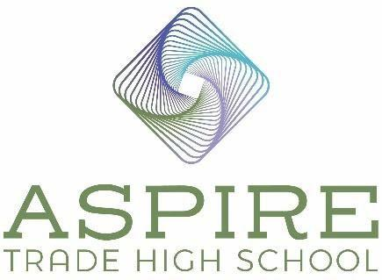

Aspire Trade High School BOD Meeting Minutes

Location: ATHS
Date: October 28, 2025
Time: 6:00 pm – 6:30 pm

In Attendance

Board Chair – Derek Partee

Vice Chair – Heidi Bertino-Daum

Principal – Jennifer Nichols

Treasurer - Jenny Miller

Secretary – Melinda Bales

Agenda Items

- Review and Approve September 23, 2025, minutes
Motion: Heidi Bertino-Daum: Motion to approve September 23, 2025 meeting minutes. Melinda Bales seconds the motion. Motion Approved: Voted Yes: Derek Partee, Heidi Bertino-Daum, Melinda Bales and Jenny Miller.

- Fall International Festival Update

Students had fun at this event, the next event for students is Homecoming. We have lots of fun activities for the students to compete in and we will have a Homecoming Court. We are putting out a video of students introducing Homecoming and Phoenix Wars to the other students. Ms. Lyall will put out a video of the International Festival, and we will play it in the lobby.

- OCS School Improvement visit and plan
Review of Strengths
School Improvement Plan and School Grade (letter to parents) – due Nov 30th

Jennifer handed out the feedback we received from the board. Our key issue is compliance. We are doing NC check-ins to help make sure students understand course content. We will do reviews, and we will follow the curriculum. The school improvement plan is due November 30th. SIT team needs to have an improvement plan ready by 11/30. We must send a letter to parents notify them of our F grade.

- Positions Available
Chemistry/Earth and Environmental Science
Behavior Management Specialist

We have two finalists for our Behavioral Management Specialist – we are checking their references and then we will make our decision. Both have behavioral management experience, and one has more policing experience. They need to use our discipline matrix – they need to be fair and equitable with their behavior management administration and enforce the consequences.

- Upcoming Events
November 6 – Virtual Open House Caterpillar Ministries
We have students referred to us by Caterpillar Ministries. They stay connected with the students who are currently attending here and let us know any needs the students or their families have. We will talk to 8th grade parents at the open house. They provide tutoring for our students.

November 7 – Aspire Homecoming (Friday 6:00-8:00)
Content teachers will chaperone.

November 9 – Trade Open House
Trade teachers will attend.

November 15 – (Saturday 5:30-8:30)
This is our big donor event. Students will do demonstrations in the classrooms.

November 20 – Trade Open House
This is for new or interested students to attend since we will be opening our lottery on December 1st. We can still take students for 9th and 10th grade enrollment in this current year before the semester ends.

- Public Comments (2-minute maximum)
Parent – Parent stated her son had been threatened by other students. She set up a meeting with Ms. Nichols who said we need to talk with you about another matter with your son. On Monday my child was not allowed in the building nor myself. Derek got the parent’s contact information and said he investigate the issue and get back to her in a few days. We can’t speak about disciplinary proceedings at the board meeting.

Parent 2 – Can students wear jackets with hoods outside? Jennifer replied yes. Parent also asked if there was an issue with the vending machines today – Derek replied not anymore.

- Schedule Next Meeting
Our next meeting is scheduled for November 18th.

- Motion to Adjourn Open Session and go into Closed Session
Motion: Derek Partee: Motion to adjourn and go into closed section as requested under 143-318.11. Closed sessions Option (6). Heidi Bertion-Daum seconds the motion. Motion Approved: Voted Yes: Heidi Bertino-Daum, Derek Partee, Melinda Bales and Jenny Miller.

- Closed Session
Closed Session Requested under 143-318.11. Closed sessions Option (6) To consider the qualifications, competence, performance, character, fitness,
conditions of appointment, or conditions of initial employment of an
individual public officer or employee or prospective public officer or
employee; or to hear or investigate a complaint, charge, or grievance by or
against an individual public officer or employee. General personnel policy
issues may not be considered in a closed session. A public body may not
consider the qualifications, competence, performance, character, fitness,
appointment, or removal of a member of the public body or another body
and may not consider or fill a vacancy among its own membership except in
an open meeting. Final action making an appointment or discharge or
removal by a public body having final authority for the appointment or
discharge or removal shall be taken in an open meeting.

